**High Level Design Subscription Based Licensing Service**

**Block Diagram**

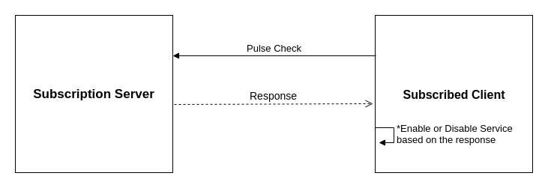

**Sequential Diagram**

